**THIS IS THE FORM WHICH SHOULD BE SUBMITTED.**

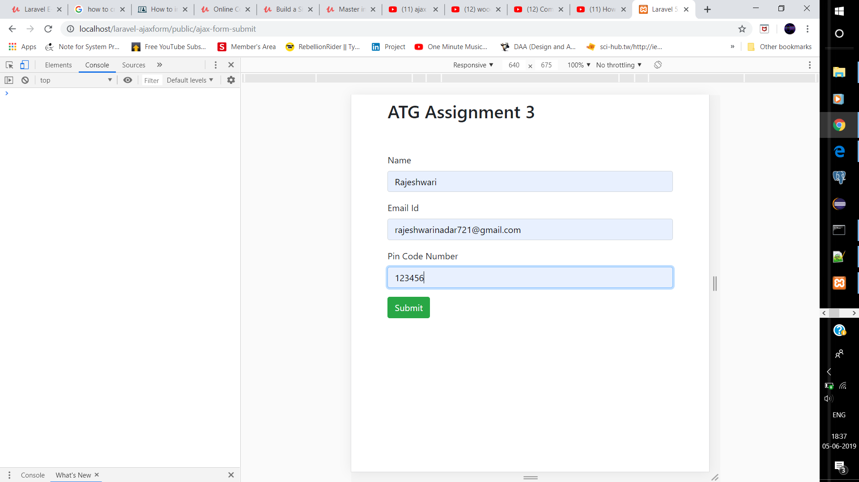

**THIS IS THE MESSAGE WHEN THE DATA GETS STORED.**

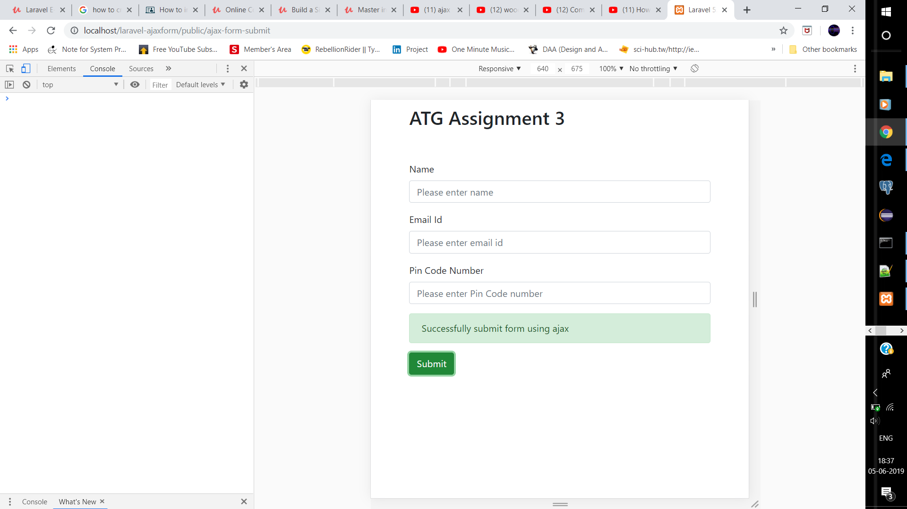

**THIS IS THE VALIDATION MESSAGES.**

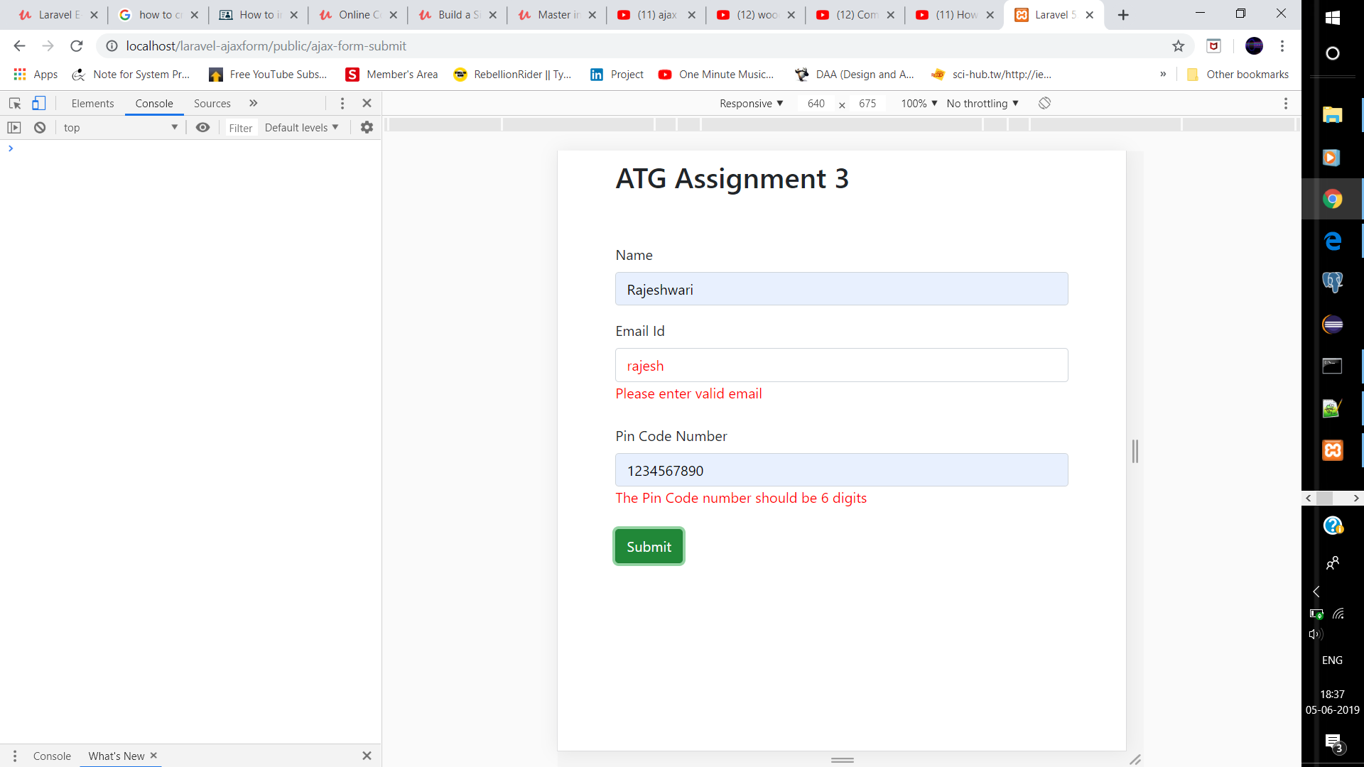

This value is send using post and through the following URL to the route and the value is getting store.

